Multi-Environment Application Deployment - Evidence Document
1. Introduction
This document describes the deployment of a multi-environment ticket management application using Docker.
The application includes:
- Frontend (React)
- Development Backend (Flask)
- Production Backend (Flask)
- MongoDB Database

2. Source Code Setup
The project was obtained from the following repository:
https://github.com/mohanDevOps-arch/MultienvApp
The repository structure was reviewed and verified before making necessary modifications.

3. Project Structure
The application follows this structure:
multiEnv/
- backend/
- dev/
- prod/
- frontend/
- docker-compose.yml
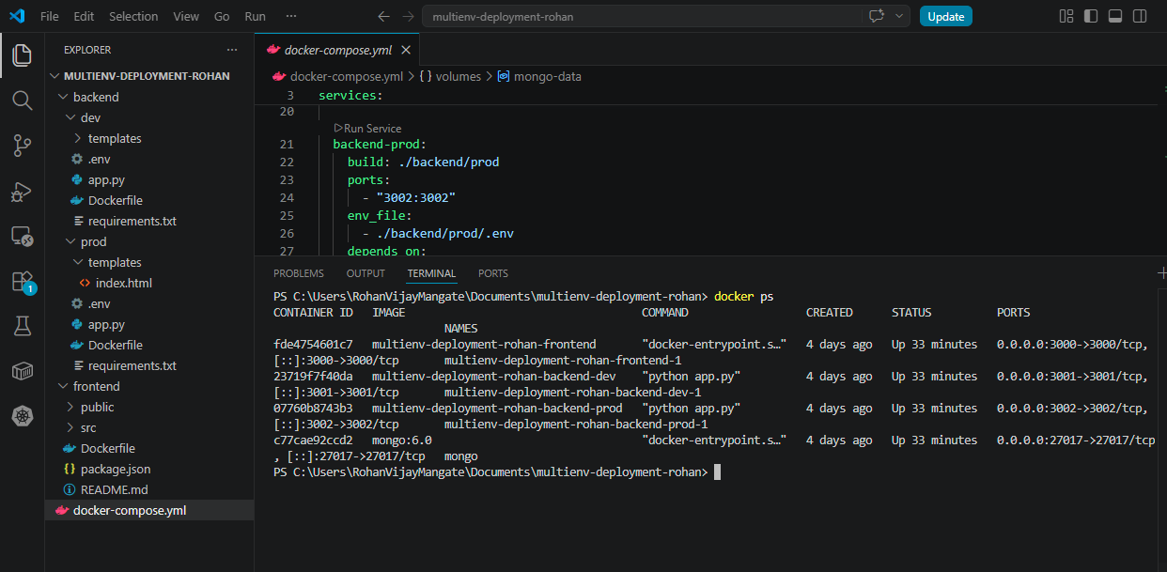

4. Docker Configuration
- Backend - Development Environment
- Created a Dockerfile in backend/dev
- Installed Python dependencies
- Configured Flask app to run on port 3001
- Added environment variables using .env
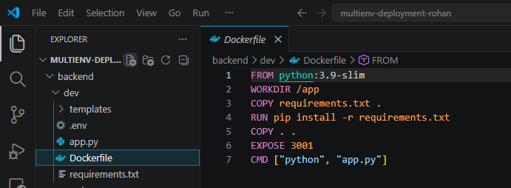

- Backend - Production Environment
- Created a Dockerfile in backend/prod
- Installed required dependencies
- Configured Flask app to run on port 3002
- Connected to MongoDB using service name
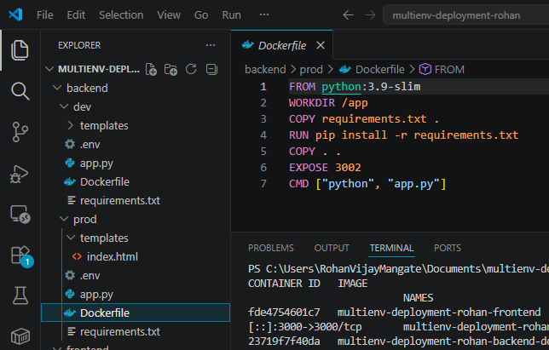

- Frontend Service
- Created Dockerfile in frontend
- Used Node.js base image
- Installed dependencies using npm install
- Served React application on port 3000
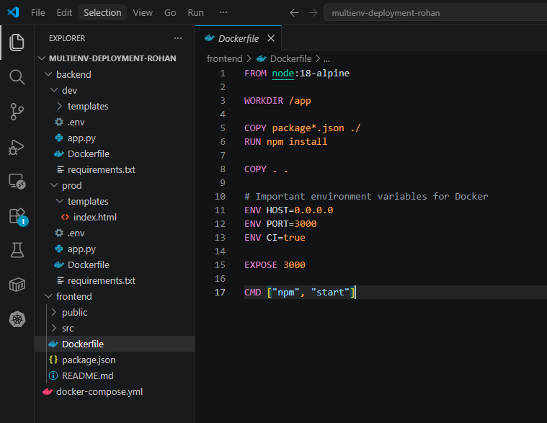

- Environment Variables
Configured .env files:
Dev:
PORT=3001
MONGO_URI=mongodb://mongo:27017/devdb
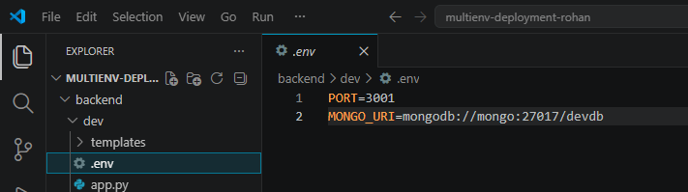

Prod:
PORT=3002
MONGO_URI=mongodb://mongo:27017/proddb
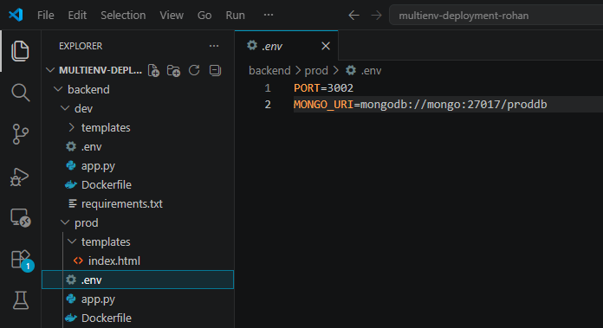

5. Docker Compose Setup
Created docker-compose.yml with services:
- frontend
- backend-dev
- backend-prod
- mongo
Each service was configured with:
- Proper ports
- Dependencies
- Environment files
- Docker network communication
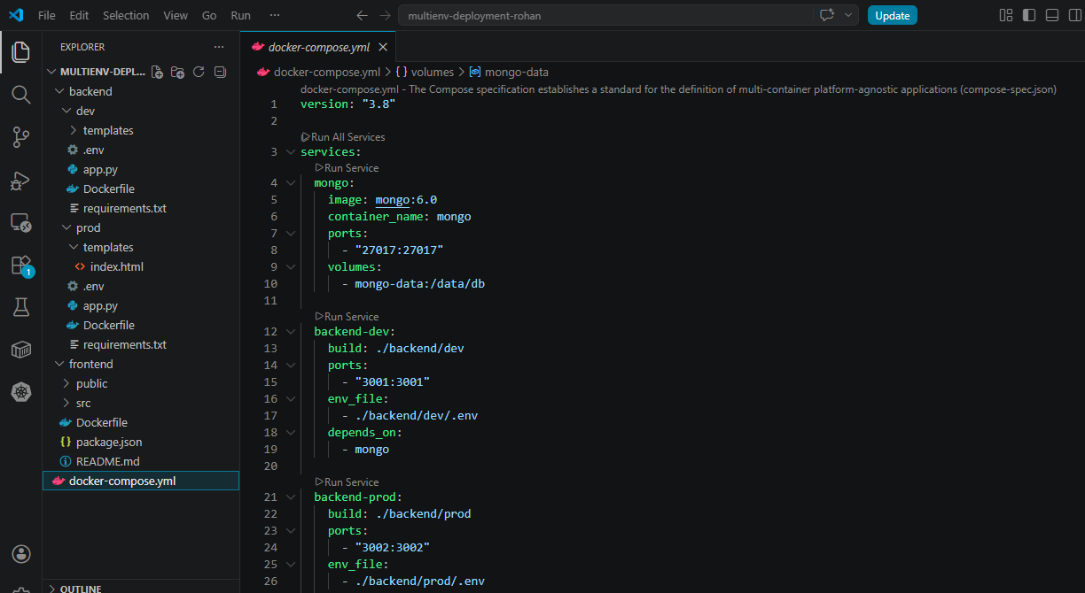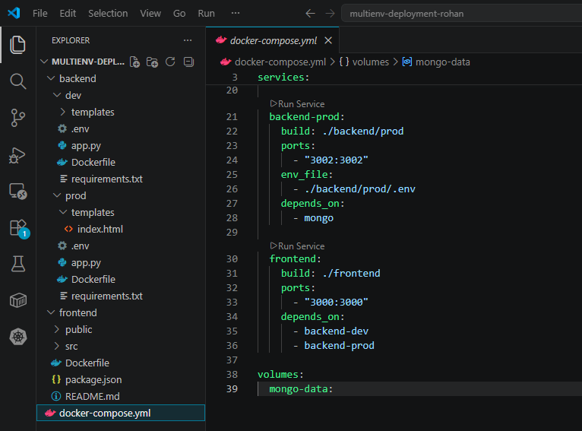

6. Application Deployment
- Step 1: Start Docker Engine
Docker Desktop was started and verified to be running.
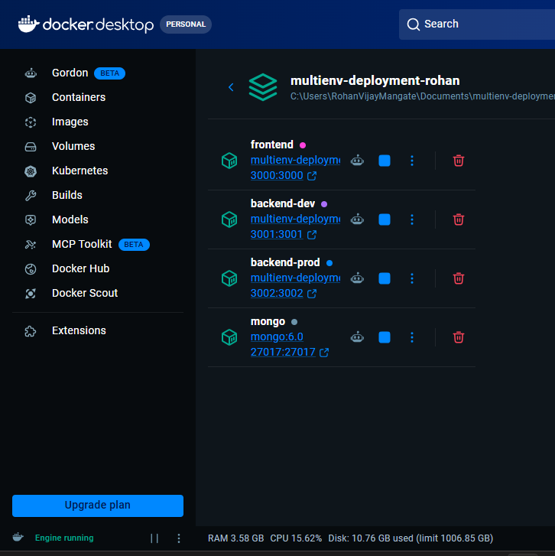

- Step 2: Build and Run Containers
The application was deployed using: docker-compose up --build

- Step 3: Verify Containers
Verified using: docker ps

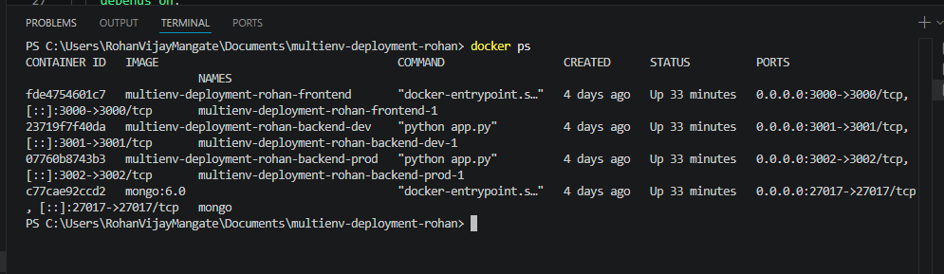
docker ps output

7. Application Access & Testing
- Frontend Access
http://localhost:3000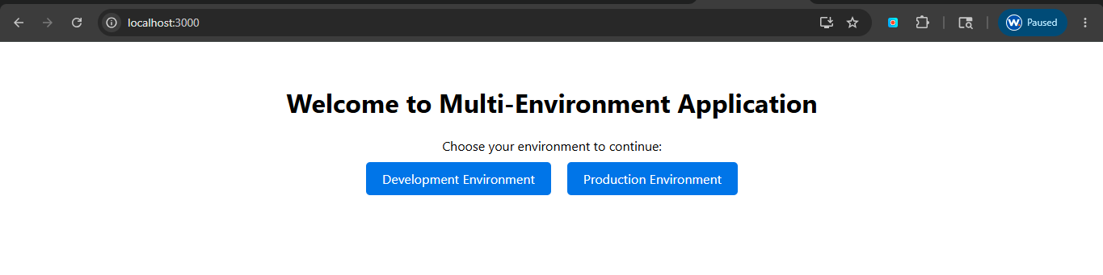

- Development Environment
http://localhost:3000/dev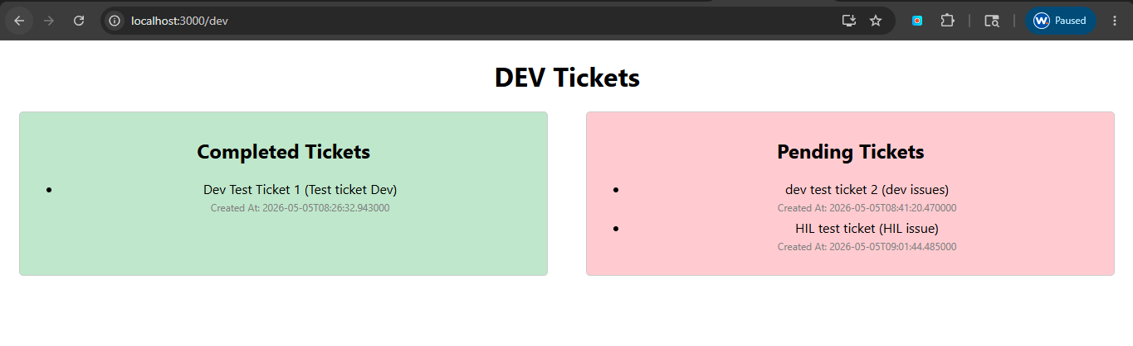

- Production Environment
http://localhost:3000/prod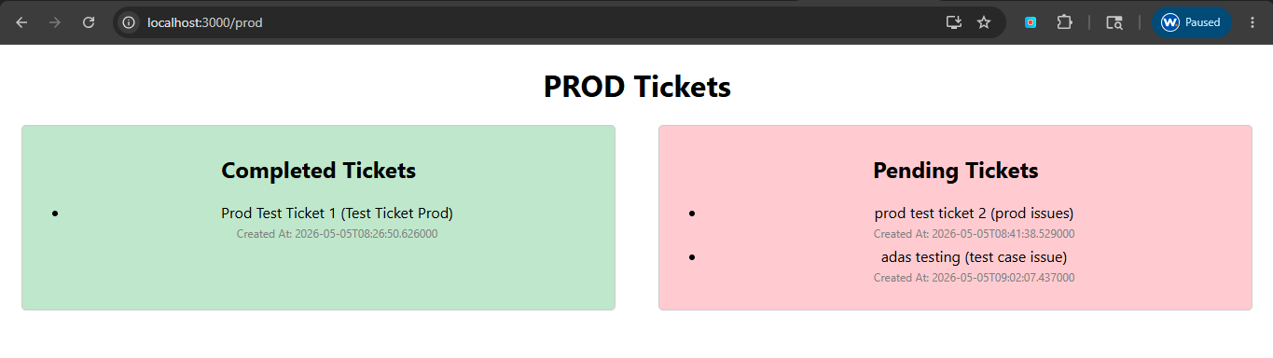

- Backend Direct Access (Additional Verification)
Development Backend:
http://localhost:3001
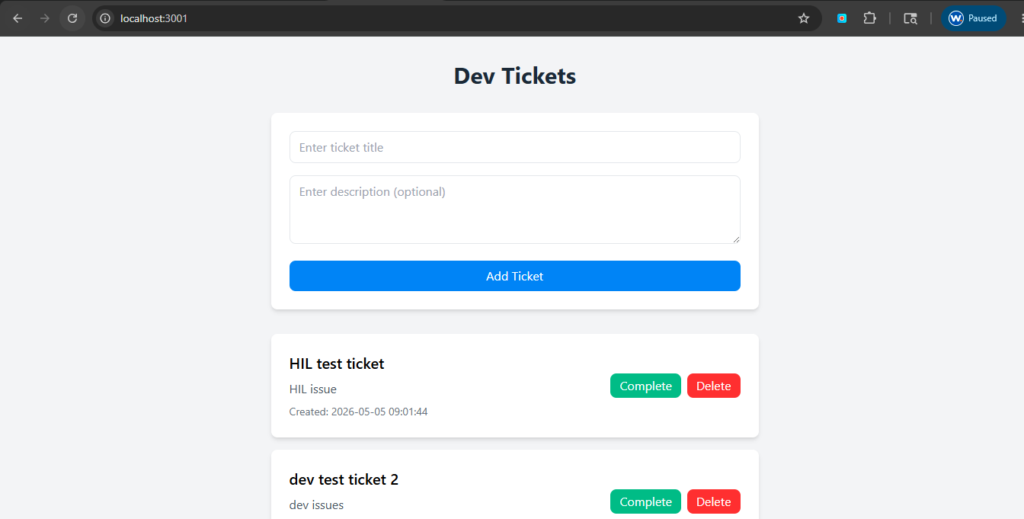

Production Backend:
http://localhost:3002
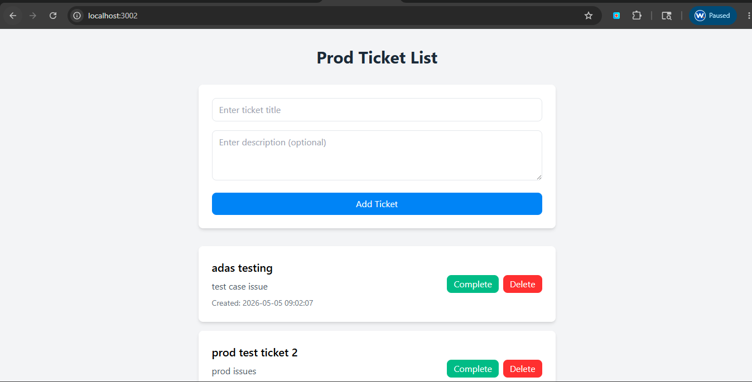

8. Logs Verification
Logs were monitored using: docker-compose logs -f
This confirmed: Services are running properly & No major errors in containers.
9. Networking & Connectivity
- Services communicate using Docker internal network
- Backend connects to MongoDB using service name mongo
- Frontend connects to backend services through defined ports

10. Assumptions
- Docker and Docker Compose were pre-installed
- Required ports (3000, 3001, 3002) were available
- Deployment was done on local environment instead of EC2

11. Challenges Faced
- Configuring Docker networking properly
- Handling environment variables across services
- Ensuring frontend communicates with both backends

12. Conclusion
The multi-environment application was successfully deployed using Docker Compose.
All services are running and communicating correctly, and the application is accessible via the defined URLs.

